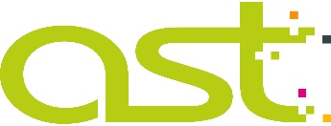
environmental POLICY
AstSigns Ltd. recognises that its business activities interact with the environment in a variety of ways. These activities have a significant impact in the key areas of:
- raw material use, energy use, and generation of waste materials.
The Company recognises that it has a responsibility to help protect the environment wherever it has an opportunity to do so, be a responsible neighbour and to provide a comfortable environment for its employees to work in.
As such, the Company is committed to:
- Continual improvement in the environmental impact of its business activities.
- Improving the environmental benefits provided by its products and services.
- Preventing pollution.
- Complying with all relevant legal, customer, and other third party requirements.
- Setting measurable environmental objectives that will help minimise its environmental impact
- Adopting best practices applicable to its activities wherever practicable.
The Company will achieve these commitments by:
- The implementation and maintenance of an Environmental Management System that is independently certified as compliant with ISO 14001:2015.
- Employing processes that identify the aspects of the Company’s business that have an environmental impact and quantifying the significance of each aspect.
- Maintaining an environmental performance improvement programme to enable the objectives to be achieved.
- Ensuring that its employees, suppliers and customers are aware of their role in supporting the Company’s commitments and environmental objectives.
- Training its employees in good environmental protection practices and encouraging employee involvement in environmental improvement initiatives.
- Continually monitoring the environmental impact of its business activities.
The implementation of this Environmental Policy is fundamental to the success of the Company’s business and must be supported by all employees as an integral part of their daily work.
This Policy is publicly available to interested external parties upon request.
Signed on behalf of the Board of Management:
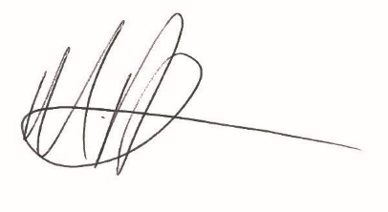
Position: Managing Director Date: 14th February 2018

